Users running IE7 will see a new security dialog (see “warning.jpg” attached) when they login to the server. The batch file mentioned in the security dialog is a part of WSUS. There is nothing wrong with the batch file (except that it is called from another batch file on a network drive); instead the problem is with IE7’s ability to accurately determine if the computer is part of an intranet. A little more information can be found here under “do I need to set anything in Internet Explorer to have intranet security”:
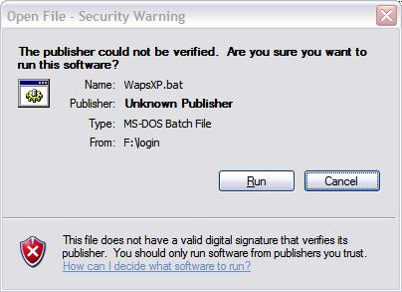
http://windowshelp.microsoft.com/Windows/en-US/Help/9cf3477e-2a6e-4c18-bf42-4ce760e952a91033.mspx

The issue can be resolved automatically by doing the following: drag the attached “AutoDetect disable.reg” file to the desktop, double click on the reg file, click YES, click OK.

The “AutoDetect enable.reg” file returns the IE settings to default.

Manually, this issue can be resolved by doing the following: open IE, expand the TOOLS menu, select INTERNET OPTIONS, click the SECURITY tab, select LOCAL INTRANET, click the SITES button, deselect AUTOMATICALLY DETECT INTRANET NETWORK, click OK, click OK.

